**Superset ID: 6394725**

**ReactJS-HOL**

**HANDS ON-5:**

My Academy team at Cognizant want to create a dashboard containing the details of ongoing and completed cohorts. A react application is created which displays the detail of the cohorts using react component. You are assigned the task of styling these react components.

Create a react app

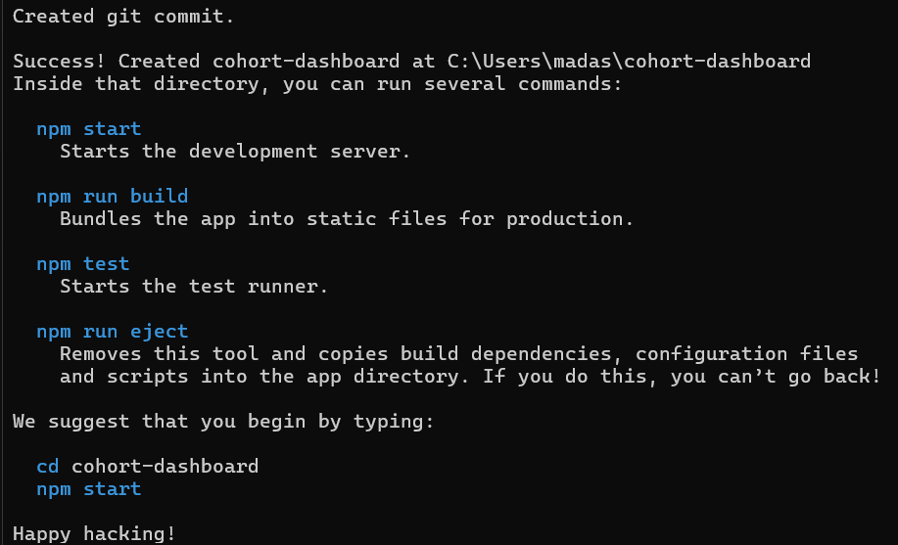

Download and build the attached react application.

1. Unzip the react application in a folder
2. Open command prompt and switch to the react application folder
3. Restore the node packages using the following commands

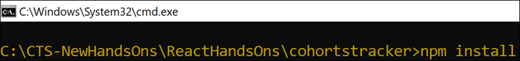

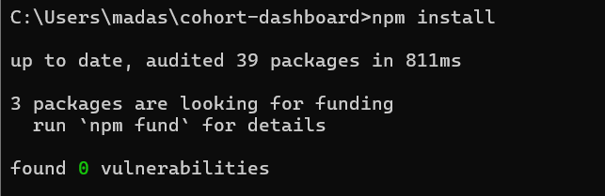

*Figure 1: Restore packages*

1. Open the application using VS Code
2. Create a new CSS Module in a file called “CohortDetails.module.css”
3. Define a css class with the name as “box” with following properties

*Width = 300px;*

*Display = inline block;*

*Overall 10px margin*

*Top and bottom padding as 10px*

*Left and right padding as 20px*

*1 px border in black color*

*A border radius of 10px*

.box {

width: 300px;

display: inline-block;

margin: 10px;

padding: 10px 20px;

border: 1px solid black;

border-radius: 10px;

}

1. Define a css style for html <dt> element using tag selector. Set the font weight to 500.

dt {

font-weight: 500;

}

1. Open the cohort details component and import the CSS Module

import React from 'react';

import styles from './CohortDetails.module.css';

const CohortDetails = ({ cohort }) => {

const isOngoing = cohort.status.toLowerCase() === 'ongoing';

return (

<div className={styles.box}>

<h3 style={{ color: isOngoing ? 'green' : 'blue' }}>

{cohort.name}

</h3>

<dl>

<dt>Status:</dt>

<dd>{cohort.status}</dd>

<dt>Start Date:</dt>

<dd>{cohort.startDate}</dd>

<dt>End Date:</dt>

<dd>{cohort.endDate}</dd>

</dl>

</div>

);

};

export default CohortDetails;

1. Apply the box class to the container div
2. Define the style for <h3> element to use “green” color font when cohort status is “ongoing” and “blue” color in all other scenarios.

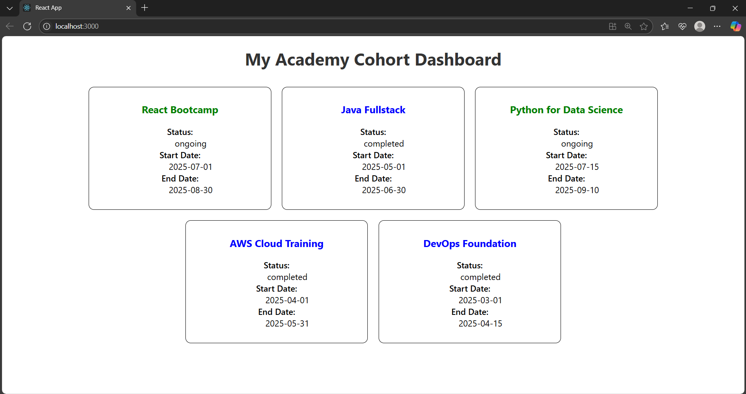

*Figure 2: Final Result*